OXO PALLADATION
The Wacker process or the Hoechst-Wacker process (named after the chemical companies of the same name) originally referred to the oxidation of ethylene to acetaldehyde by oxygen in water in the presence of a tetrachloropalladate catalyst.^{[1]} The same basic reaction is currently used to produce aldehydes and ketones from a number of alkenes with the Monsanto process for producing acetic acid. This chemical reaction, a German invention, was the first organometallic and organopalladium reaction applied on an industrial scale. The Wacker process is similar to hydroformylation, which is also an industrial process and also leads to aldehyde compounds. The differences are that hydroformylation promotes chain extension, and uses a rhodium-based catalyst system. The Wacker process is an example of homogeneous catalysis. The palladium complex with ethylene is reminiscent of Zeise's salt, K[PtCl₃(C₂H₄)] which is a heterogeneous catalyst

History
The development of the chemical process now known as the Wacker process began in 1956 at Wacker Chemie.^{[2]} At the time, many simple aliphatic compounds were produced from acetylene (as calcium carbide) but the construction of a new oil refinery in Cologne by Esso close to a Wacker site, combined with the realization that ethylene would be a cheaper raw-material prompted Wacker to investigate its potential uses. As part of the ensuing research effort, a reaction of ethylene and oxygen over palladium on carbon in a quest for ethylene oxide unexpectedly gave evidence for the formation of acetaldehyde (simply based on smell). More research into this ethylene to acetaldehyde conversion resulted in 1957 in a gas-phase reaction patent using a heterogeneous catalyst.^{[3]} In the meanwhile Hoechst AG joined the race and after a patent filing forced Wacker into a partnership called Aldehyd GmbH. The heterogeneous process ultimately failed due to catalyst inactivation and was replaced by the water-based homogeneous system for which a pilot plant was operationally in 1958. Problems with the aggressive catalyst solution were solved by adopting titanium (newly available for industrial use) as construction material for reactors and pumps. Production plants went into operation in 1960.

Reaction mechanism
The reaction mechanism for the industrial Wacker process (olefin oxidation via palladium(II) chloride) has received significant attention for several decades, and parts of it are still a contentious subject. A modern formulation is described below:
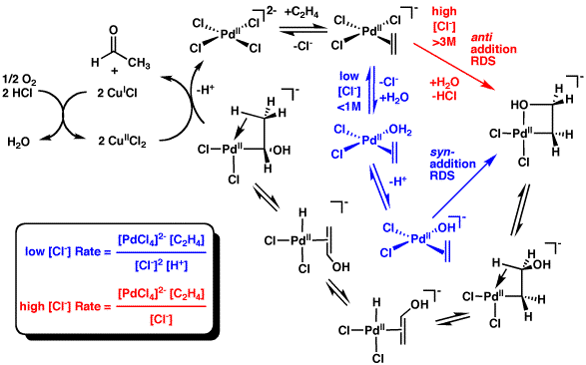
The catalytic cycle can also be described as follows:
[PdCl₄]² ⁻ + C₂H₄ + H₂O → CH₃CHO + Pd + 2 HCl + 2 Cl⁻
Pd + 2 CuCl₂ + 2 Cl ⁻ → [PdCl₄]²⁻ + 2 CuCl
2 CuCl + ½ O₂ + 2 HCl → 2 CuCl₂ + H₂O
Note that all catalysts are regenerated and only the alkene and oxygen are consumed. Without copper(II) chloride as an oxidizing agent Pd(0) metal (resulting from reductive elimination of Pd(II) in the final step) would precipitate out and the reaction would come to a halt (the stoichiometric reaction without catalyst regeneration was discovered in 1894). Air, pure oxygen, or a number of other oxidizers can then oxidise the resultant CuCl back to CuCl₂, allowing the cycle to repeat.
The initial stoichiometric reaction was first reported by Phillips^{[4][5]} and the Wacker reaction was first reported by Smidt et al.

