A Ziegler–Natta catalyst, named after Karl Ziegler and Giulio Natta, is a catalyst used in the synthesis of polymers of 1-alkenes (α-olefins). Two broad classes of Ziegler–Natta catalysts are employed, distinguished by their solubility:
- Heterogeneous supported catalysts based on titanium compounds are used in polymerization reactions in combination with cocatalysts, organoaluminum compounds such as triethylaluminium, Al(C2H5)3. This class of catalyst dominates the industry.
- Homogeneous catalysts usually based on complexes of Ti, Zr or Hf. They are usually used in combination with a different organoaluminum cocatalyst, methylaluminoxane (or methylalumoxane, MAO). These catalysts traditionally include metallocenes but also feature multidentate oxygen- and nitrogen-based ligands.
Ziegler–Natta catalysts are used to polymerize terminal 1-alkenes (ethylene and alkenes with the vinyl double bond):
n CH2=CHR → −n−

Coordination (Ziegler-Natta) Polymerization

Early work:
Insertion of aluminum alkyls into olefins was studied by Ziegler:
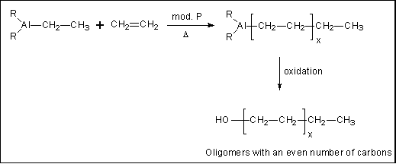
Important discovery: R3Al + Lewis acids:
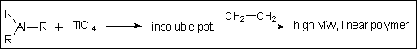
Another important discovery: tacticity control:
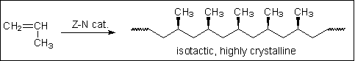
Results:
- Nobel Prize in Chemistry for Zeigler and Natta (1963)
- Multibillion $ industry

Overall Scheme of Coordination Polymerization
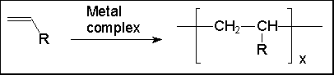
- Limited to ethylene and other a-olefins like propylene. (Actually, it is the only good way to polymerize these monomers.)
- Produces linear polymer, with very few branches (e.g., high density polyethylene, HDPE).
- Capable of producing homo-tactic polymers.
- Most commercial initiators are insoluble complexes or supported on insoluble carriers.
- Very complex mechanism, still poorly understood for the heterogeneous systems.
- Termination is almost exclusively by chain transfer.
- Modern "high mileage" initiators produce up to 1000's of kg per g initiator.
- Initiators are often called "catalysts" even though they are consumed by the process. Many chains are started per molecule of initiator.

Mechanism of Coordination Polymerization
The mechanism is poorly understood because it takes place on the surface of an insoluble particle, a difficult situation to probe experimentally. The mechanism shown below is one of several models proposed to at least partially explain the action of the Ziegler-Natta systems, but it is only an approximation of the more complex process that actually occurs.
